**Topics: Descriptive Statistics and Probability**

1. Look at the data given below. Plot the data, find the outliers and find out $μ, σ, σ^{2}$

|  |  |
| --- | --- |
| **Name of company** | **Measure X** |
| Allied Signal | 24.23% |
| Bankers Trust | 25.53% |
| General Mills | 25.41% |
| ITT Industries | 24.14% |
| J.P.Morgan & Co. | 29.62% |
| Lehman Brothers | 28.25% |
| Marriott | 25.81% |
| MCI | 24.39% |
| Merrill Lynch | 40.26% |
| Microsoft | 32.95% |
| Morgan Stanley | 91.36% |
| Sun Microsystems | 25.99% |
| Travelers | 39.42% |
| US Airways | 26.71% |
| Warner-Lambert | 35.00% |

Answer:

Mean of X($μ$)=0.332713

Standard deviation($σ$)=0.169454

Variance($σ^{2}$)=0.028715

Outliers: morgan stanley-91.36%

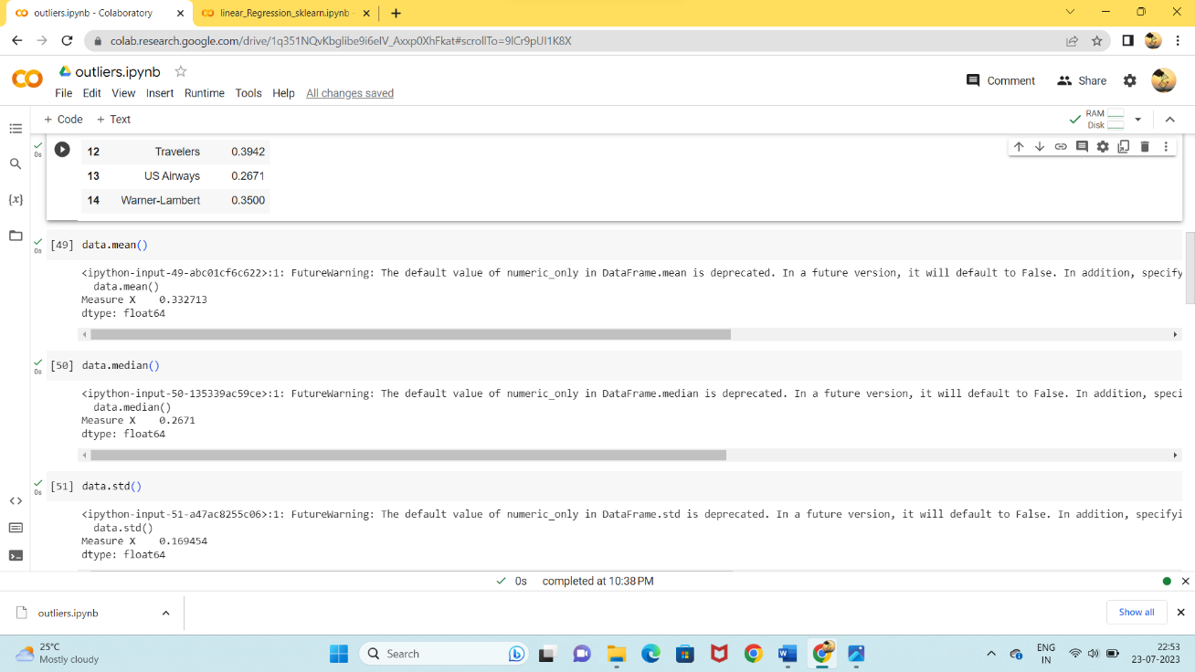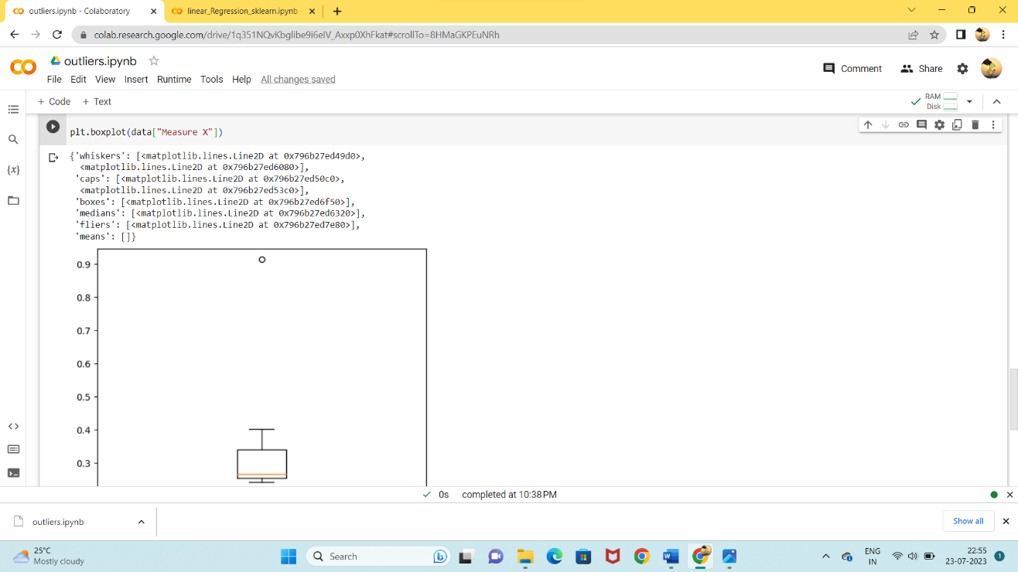



Answer the following three questions based on the box-plot above.

1. What is inter-quartile range of this dataset? (please approximate the numbers) In one line, explain what this value implies.

Inter-quartile range=12-5=7

It is the median of the dataset.

1. What can we say about the skewness of this dataset?

It is the positive skewers(right tail)

1. If it was found that the data point with the value 25 is actually 2.5, how would the new box-plot be affected?

Median & mean remains same.

Outliers will not be there.

Inter-quartile range will be affected.



Answer the following three questions based on the histogram above.

1. Where would the mode of this dataset lie?

Answer: It will lies between 5-10.

1. Comment on the skewness of the dataset.

Answer: It is the positive skewers(right tail)

1. Suppose that the above histogram and the box-plot in question 2 are plotted for the same dataset. Explain how these graphs complement each other in providing information about any dataset.

Answer:

Both have outliers.

It has right skewers.

It affects the mean and median. But it will be normally distributed

1. AT&T was running commercials in 1990 aimed at luring back customers who had switched to one of the other long-distance phone service providers. One such commercial shows a businessman trying to reach Phoenix and mistakenly getting Fiji, where a half-naked native on a beach responds incomprehensibly in Polynesian. When asked about this advertisement, AT&T admitted that the portrayed incident did not actually take place but added that this was an enactment of something that “could happen.” Suppose that one in 200 long-distance telephone calls is misdirected. What is the probability that at least one in five attempted telephone calls reaches the wrong number? (Assume independence of attempts.)

Answer:

Probability of making 1 wrong call=1/200

Probability of not wrong calls=199/200

Probability that atleast one in five attempts=5c1p^x q^n-x

=5c1*1/200*(199/200)^4

=5*.005*(0.98)

=0.0245

1. Returns on a certain business venture, to the nearest $1,000, are known to follow the following probability distribution

|  |  |
| --- | --- |
| x | P(x) |
| -2,000 | 0.1 |
| -1,000 | 0.1 |
| 0 | 0.2 |
| 1000 | 0.2 |
| 2000 | 0.3 |
| 3000 | 0.1 |

1. What is the most likely monetary outcome of the business venture?

2000 is mostly likely monetary outcome of the business venture and its probability is 0.3

1. Is the venture likely to be successful? Explain

Yes the venture is likely to be successful. Because the profit is about 0.8 which means 80% it is more than 0.

1. What is the long-term average earning of business ventures of this kind? Explain

(-2000*0.1)+(-1000*0.1)+(1000*0.2)+(2000*0.3)=800 .This is the average earning of business ventures.

1. What is the good measure of the risk involved in a venture of this kind? Compute this measure

The risk is 0.2 which is 20% (0.1+0.1=0.2)